Bloom’s Knowledge Dimensions | SOLO Taxonomy
Bloom’s Knowledge Dimensions |  |  | 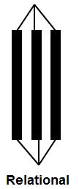 | 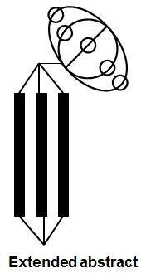
Factual & Conceptual Knowledge
Subject Procedural Knowledge
Metacognitive Knowledge

